Lab 3
SDEV 300/6381
Name: Alexander Sheidu
Date: 1/28/2024

This programming project involves creating a menu application, with 4 menu options and an exit menu option (5 options in total) and it involves the 50 U.S. states.

Test Case | Input | Expected Output | Actual Output | Pass?
Test table #1, indicating all of the input and output, for Lab #3
1 | 1, 5 | All of the 50 states  Thank you for using the States App! | All of the 50 states  Thank you for using the States App! | Yes
2 | 2, South Carolina, 5 | Please enter the name of the state to search: South Carolina  Capital: Columbia, State Population: 138224, Flower: Yellow Jessamine  Image Path: south carolina.png  Thank you for using the States App! | Please enter the name of the state to search: South Carolina  Capital: Columbia, State Population: 138224, Flower: Yellow Jessamine  Image Path: south carolina.png  Thank you for using the States App! | Yes
3 | a, 3, f | The graph,  Thank you for using the States App! | The graph,  Thank you for using the States App! | Yes
4 | 4, California, 2223457, 3, 5 | Please enter the name of the state to update its population: California  Please enter its population to update: 2223457,  The graph,  Thank you for using the States App! | Please enter the name of the state to update its population: California  Please enter its population to update: 2223457,  The graph,  Thank you for using the States App! | Yes
5 | 5 | Thank you for using the States App! | Thank you for using the States App! | Yes

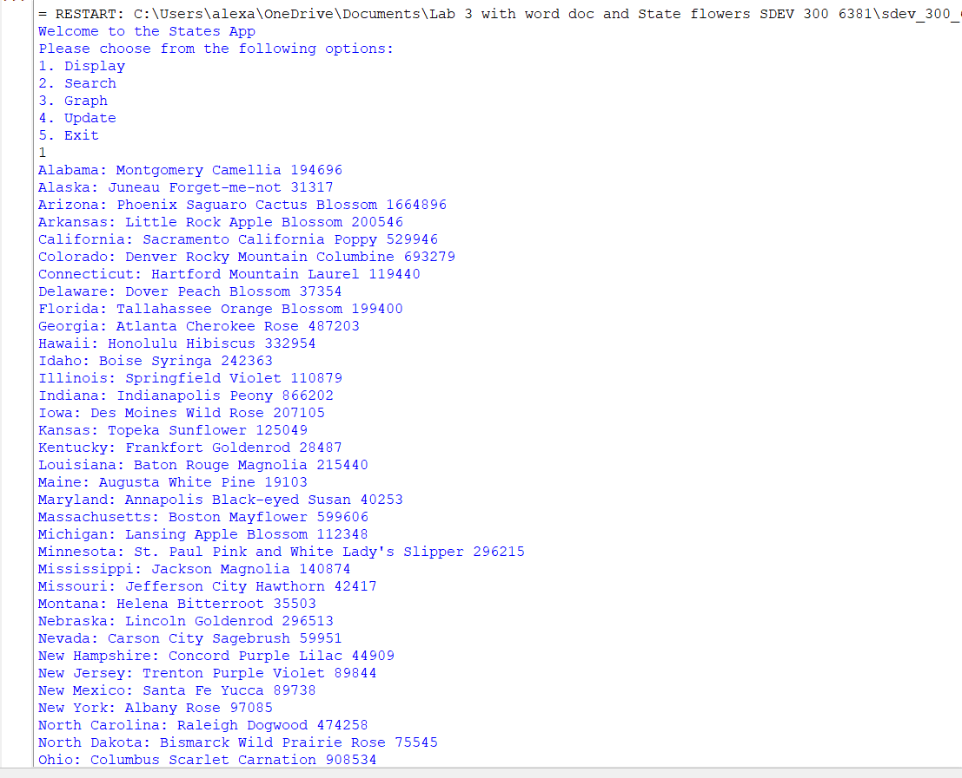
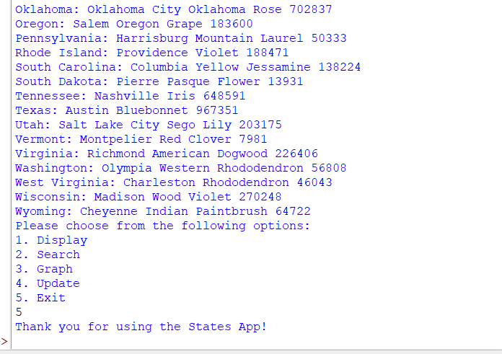
I used the first option to display all of the states and their given information.
Screenshot #1 part 1, indicating all of the input and output, for Lab #3
(Continuation) I used the first option to display all of the states and their given information.

Screenshot #1 part 2, indicating all of the input and output, for Lab #3
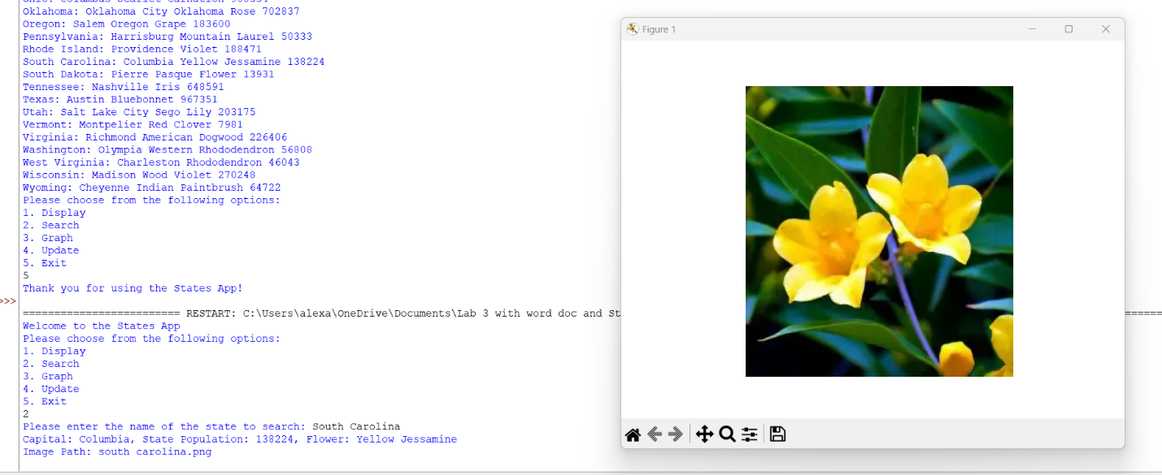
I used the second option in the menu to search for any of the states and provide their given information.

Screenshot #2 part 1, indicating all of the input and output, for Lab #3

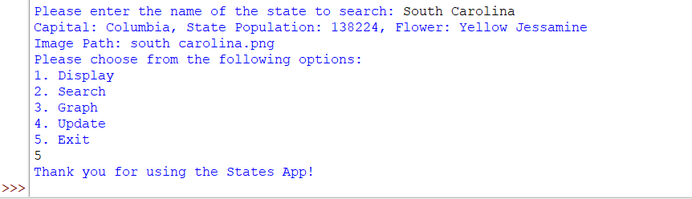
Screenshot #2 part 2, indicating all of the input and output, for Lab #3

(Continuation) I used the second option in the menu to search for any of the states and provide their given information.

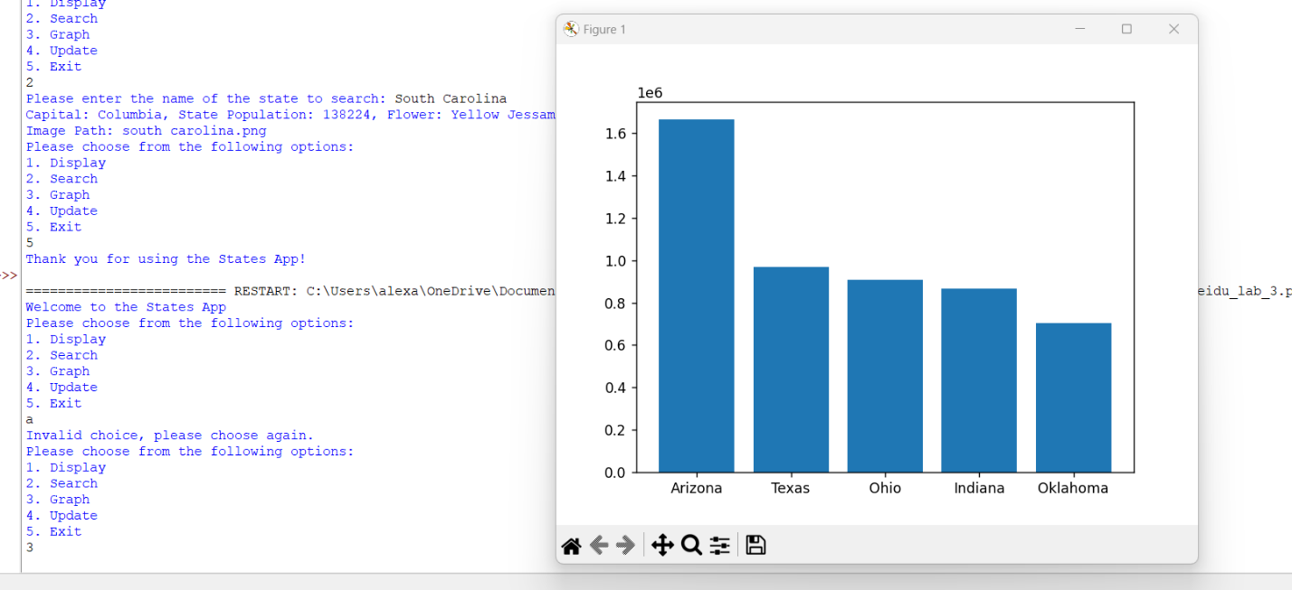
Screenshot #3 part 1, indicating all of the input and output, for Lab #3

The third choice of the menu is the graph, this graphs the top 5 populated states in the country.

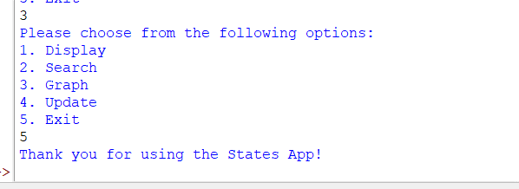
Screenshot #3 part 2, indicating all of the input and output, for Lab #3

(Continuation) The third choice of the menu is the graph, this graphs the top 5 populated states in the country.

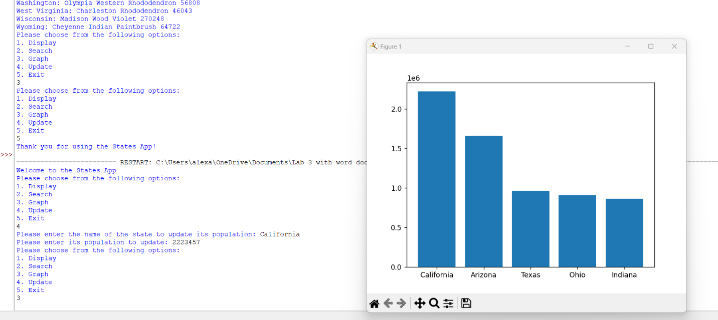
Screenshot #4 part 1, indicating all of the input and output, for Lab #3

The fourth choice of the menu is the update, this allows for the user to update the population of the state’s capital, as you can see, I made it so California’s capital is 2223457, so it took the first populated capital in the state spot.

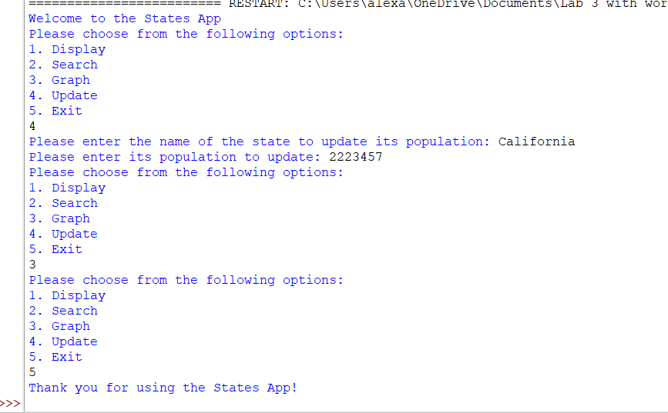
Screenshot #4 part 2, indicating all of the input and output, for Lab #3

(Continuation) The fourth choice of the menu is the update, this allows for the user to update the population of the state’s capital, as you can see, I made it so California’s capital is 2223457, so it took the first populated capital in the state spot.

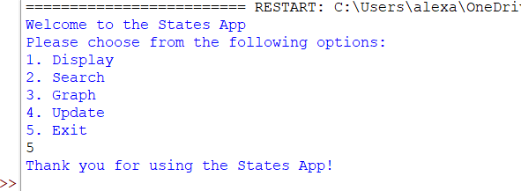
Screenshot #5, indicating all of the input and output, for Lab #3

The fifth and final choice exits out of the menu. It basically exits the program.

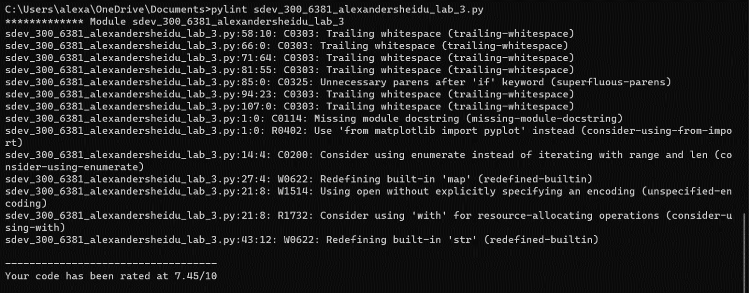
This was my first pylint score, I was a bit surprised and not sure how to fix it.
Screenshot #1, of pylint score, for Lab #3
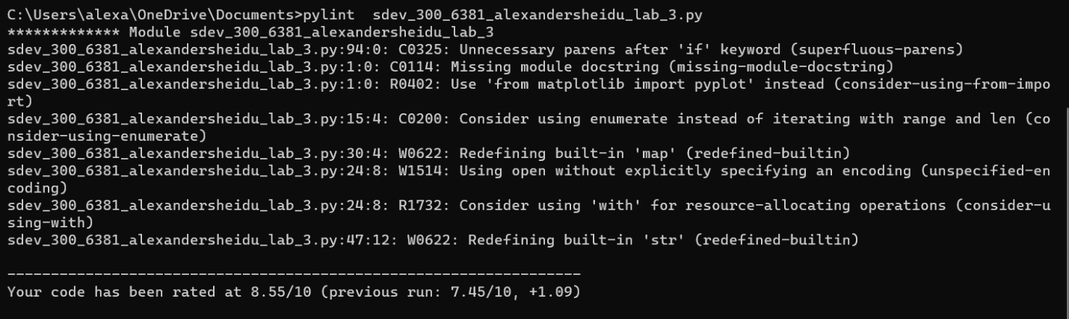
Screenshot #2, of pylint score, for Lab #3
This was my second pylint score, I understood some of the errors, and was unsure how to fix them and incorporate them in my code.
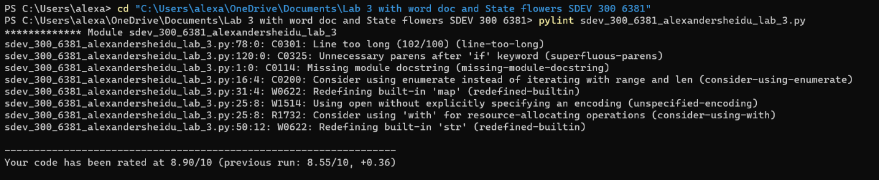
This was my third pylint score, I used the Windows Powershell, and I got a higher pylint score after removing the whitespaces that were unnecessary.

Screenshot #3, of pylint score, for Lab #3
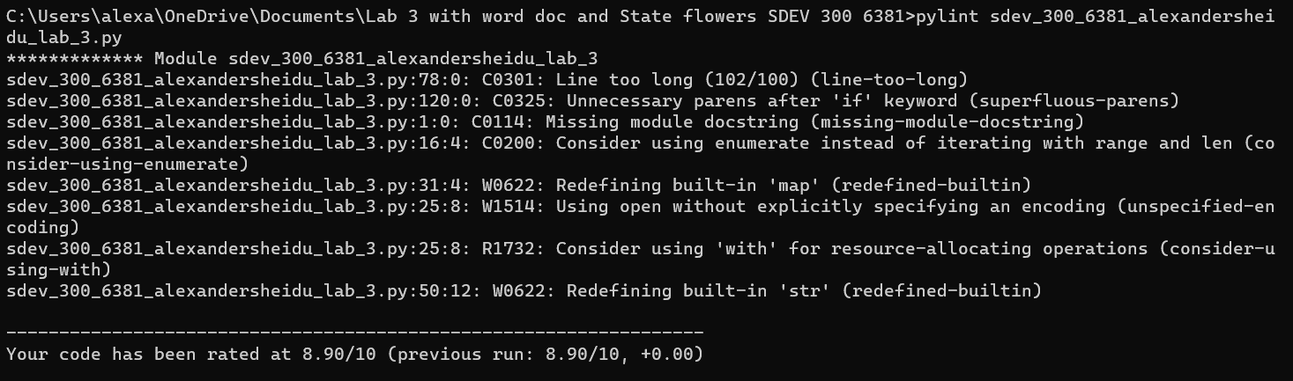
Screenshot #4, of pylint score, for Lab #3
This was my fourth pylint score, I used the Command prompt, like I did for the first through third screenshots. I ended up getting the same score, after not realizing what I had mistakenly done.

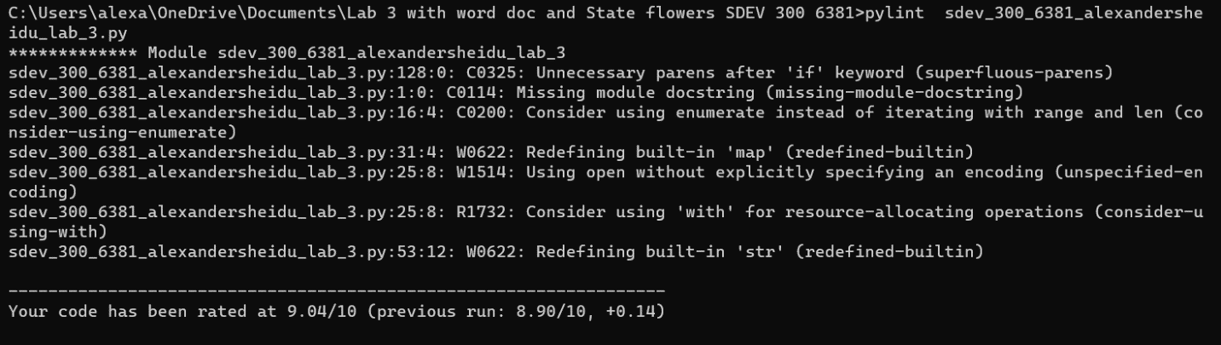
This was my fifth pylint score, I used the Command prompt, once again like I did for most of the screenshots. I made sure my comment or print statement was not too long.

Screenshot #5, of pylint score, for Lab #3

